**Instructions for authors - ET²eR**

**First Author1, Second Author2**

1Affiliation, Full address (street, city, country), e-mail address

2Affiliation, Full address (street, city, country), e-mail address

**Abstract**

*The editorial board accepts unpublished papers in Croatian and/or English. Papers are to be submitted in electronic form according to instructions available on the journal's website. The editorial board reserves the right to adapt the paper to the general rules of journal editing and Croatian/English language standards. The abstract should contain between 100 and 300 words. In the abstract, the background of the issue, methodology and results of the paper should be stated. The abstract should not contain references, figures, tables, graphs, etc.*

**Keywords**

*list 3 do 5 keywords, alphabetically, separated by commas*

Introduction

You are advised to use this document accurately as a template in ‘Microsoft Word’. The paper must include: title, name(s) of the author(s), affiliation/name of the institution, full address, abstract, keywords, introduction, the body of the paper with headings and subheadings (if any), conclusion, list of references and possible appendices. Mark the sections and subsections with Arabic numerals. Papers can contain a minimum of 5 and a maximum of 8 pages. Papers are to be submitted through the Indico system (<https://indico.vuv.hr>) while all additional instructions can be obtained via the e-mail address [urednik@vuv.hr](mailto:urednik@vuv.hr) or by phone at +385 33 492 257.

1. Technical guidelines

It is necessary to use the ‘PT Sans’ typeface. Follow the letter size specified in Table 1 (expressed in points – pt).

Prepare the final version of your paper for publishing on A4 paper size (210 mm x 297 mm).

For the page format, specify the top and bottom margins to 25 mm, and the left and right margin to 20 mm. The width of each of the two columns must be 82 mm. The distance between them will be 6 mm. Align the left and right border of the text (*justify*). Set the same length of columns on the last page of the paper. Use two blank rows between the sections, as well as between the text and the tables (Table 1) or figures (Figure 1) to adjust the length of the column. Use single spacing and adjust tab to 0.5 cm. The spacing between the headings and subheadings of the section should be 1.5 cm. Headings and subheadings are written in bold and numbered, while subheadings are also written in italics.

***TABLE 1: FONT SIZE FOR PAPERS READY TO BE PUBLISHED***

|  |  |  |  |
| --- | --- | --- | --- |
| Font | Letters type | | |
| size | regular | bold | italic |
| 8pt | references, text in tables, footno-tes, exponents and indexes | captions of figures and tables,  description of the program code | captions of figures and tables, sources of figures and tables,  description of the program code |
| 8.5t | program code |  |  |
| 10pt | author’s affiliation, address, e-mail, body of the paper |  | abstract, keywords, formulas |
| 12pt |  | section headings and subheadings | section subheadings |
| 18pt |  | title of the paper |  |

*Source: indicate the source for each table*

Use automatic word separation from row to row and use spelling and grammar check. Digitize your images.

* 1. Images, drawings, tables, graphs, and charts

Number each image, table, drawing, graph, or chart. It is recommended to place images or tables at the top or bottom of the column. Avoid placing them in the middle of the column. Figures or tables can be expanded across both columns, if necessary. The captions of the images, tables, drawings, graphs, and charts must be indicated above, and the sources must be indicated below the image, table, drawing, graph, or chart. Note: captions and sources are not centred but written from the beginning of the row (aligned left).

Use the function Reference > Insert caption (table, graph, image) to insert captions of corresponding images, tables, drawings, graphs, or charts properly.

Avoid placing figures or tables before their first mention in the text. The abbreviation "Fig. 1.” can also be used at the beginning of a sentence.

***FIGURE 1: CAPTION FOR EACH FIGURE IN THE PAPER, BOLD, ITALIC, 8 PT, ALIGNED LEFT* 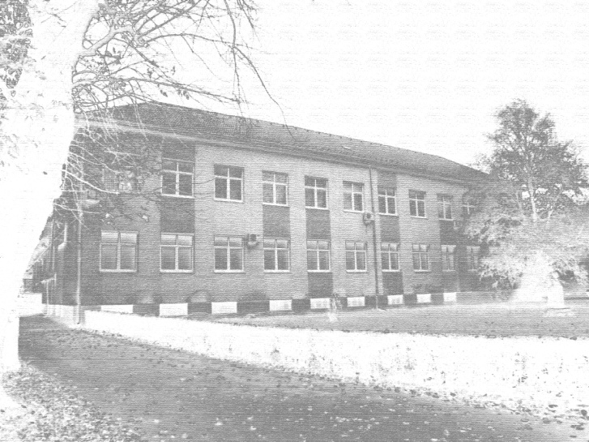**

*Source: indicate the source for each image, drawing and graph (italics, 8 pt, left alignment)*

* 1. Footnotes

Mark the footnotes with numbers[1]. Explicatory and comparative types of footnotes can be used in the text.

* 1. Citations

Referenced authors should be mentioned in the text by linking citations with the bibliographic unit (Harvard style) directly. Examples for citing: for a single author (Buble, 2006:156) for two authors (Heđi and Jukić, 2010:162), for three or more authors (Raletić et al., 2013:41). An example for paraphrasing: for a single author (Buble, 2006), for two authors (Heđi and Jukić, 2010), for three or more authors (Raletić et al., 2013).

* 1. Abbreviations and acronyms

When mentioning a term for the first time, it is necessary to state the full expression and state the abbreviation in brackets, for example, ‘information and communication technologies (ICT)’. In the rest of the text, only the acronym can be used. In the headings of sections and subsections it is mandatory to use the full expression.

For papers written in Croatian, a foreign term is to be mentioned in the text in the Croatian language first, and then, in brackets, in the original language, but in italics, for example "Institut inženjera elektrotehnike i elektronike (IEEE, eng. *Institute of Electrical and Electronics Engineers*)".

* 1. Program codes

To format text which is a program code (algorithm, pseudolanguage), use Consolas font size 8.5 pt, single spacing, left alignment, indent 6 pt. A description must be added above the program code (font ‘PT Sans’ is to be used, 8 pt, bold, italics), and, if necessary, the source must be added, as with figures and tables. To format program codes, it is best to use one of Microsoft's Add-ins (e.g., Easy Code Formatter is a recommended tool), which can be easily installed from the Insert > Get Add-ins shortcut. The example below was formatted using the Easy Code Formatter tool. It is preferable that the entire program code should be on one separate page, except for large codes when this is not possible.

***Code snippet 1: An example of writing a code***

1. #include<iostream>
2. #include<string.h>
3. using namespace std;
4. int main()
5. {
6. char pass[20], ePass[20];
7. int numOne, numTwo, sum;
8. cout<<"Create a Password: ";
9. cin>>pass;
10. cout<<"\nEnter Two Numbers to Add: ";
11. cin>>numOne>>numTwo;
12. cout<<"\nEnter the Password to See the Result: ";
13. cin>>ePass;
14. if(!strcmp(pass, ePass))
15. {
16. sum = numOne + numTwo;
17. cout<<endl<<numOne<<" + "<<numTwo<<" = "<<sum;
18. }
19. else
20. cout<<"\nSorry! You've entered a Wrong Password!";
21. cout<<endl;
22. return 0;
23. }
    1. Formulas and equations

To enter formulas, use the Equation Editor within the Microsoft Word program. Equations must be centred and numbered; the numbering must be placed along the right margin in brackets as in the example below.

$y=a⋅x^{2}$ (1)

1. Conclusion

Be brief and state the most important conclusion of your paper. Do not use formulas or figures in this section. Please note that papers which are not written according to the instructions above will not be accepted for publication in the journal. It is mandatory to complete the author's consent form for the use of personal data/authorship statement of the paper.

Please visit <https://vuv.hr/et2er/> for paper submission guidelines and stated deadlines.

References

1. Buble, M. (2006): Menadžment. Split: Ekonomski fakultet
2. Blažević, Z., Bosnić, I. (2009): Ruralni turizam u općini Pitomača. U: Bedeković, V. (ur) Zbornik radova Visoke škole za menadžment u turizmu i informatici. Virovitica: Visoka škola za menadžment u turizmu i informatici u Virovitici (str. 157-166)
3. Heđi, I., Jukić, O. (2010): Informacijski sustav za samostalno kreiranje turističkih aranžmana. In: Lučić, B., Jojić, R., Šarenac, M. (eds.) ICTE 2010 International conference on turism and environment. Sarajevo: IUPNB (pp 159-164)
4. Jukić, O., Špoljarić, M. (2010): Uvod u građu računala. Virovitica: Visoka škola za menadžment u turizmu i informatici u Virovitici
5. Raletić, S., Janjušić, D., Garača, N., (2013): Metode za mjerenje različitih oblika promocije preko interneta. Praktični menadžment Vol IV br. 1 (33-42)
6. Schiller, B.R. (2006): The Micro Economy today. New York: McGraw-Hill/Irwin
7. Zakon o zaštiti tržišnog natjecanja, NN 122/03
8. Poslovni dnevnik, http://www.poslovni.hr/ (20.05.2018)

1. Footnotes can be of explicatory or comparative type, font 'PT Sans', size 8.